## Micron Handpiece Design Considerations

**Revisions:**

**R3** (11 March 16)**:** New sections: **mechanical overload robustness**, **output plate**, **tool holder.** Added discussion of LED electrical interface in **LED flex**

**R2** (08 March 16)**:** New section **magnetic compatibility**, large changes in **mass issues**.

**R1** (04 March 16)**:** Initial revision

Todo:

Weight without cable?

Photos of break-down?

Work in Sungwook Merlet analysis?

More pointers to design files:

LED mounts and/or flex outline

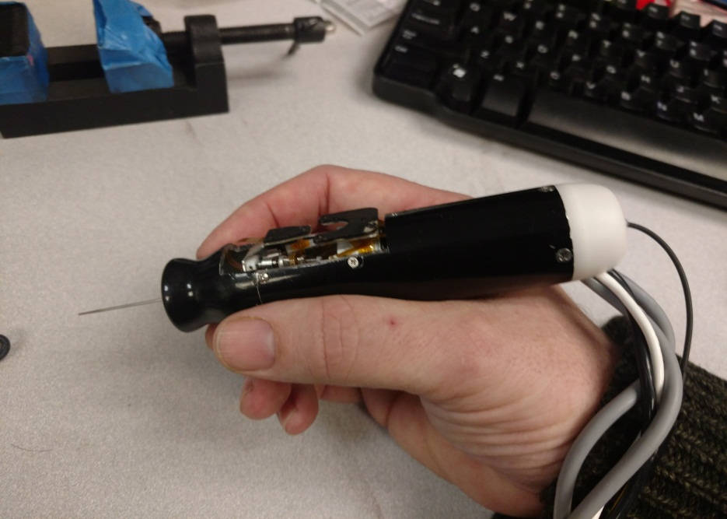

Finger Notch

LED mounts

Housing front

Housing tube

Housing plug

Offset cable leadout

Center fiber conduit leadout

Output plate

Base plate

This photo shows the three main parts of the current housing design: front, tube, and plug, with ergonomic features. Note how the handpiece sits in the hand, and the cables lay on the wrist for support, so that the cable weight doesn’t torque the handpiece. The housing front part is mainly an ergonomic feature, but also has an important role as a reaction mass. Note how it sticks out in front of the output plate. This is not mechanically desirable because it requires a longer tool, increasing the moment at the tool tip and at the side load point (remote center of motion or RCM), but this extension of the housing in front allows it to have the reduced radius finger notch, which gives a more desirable grip in the hand. The housing tube extends a considerable distance back from the manipulator base, giving room for electronics, cable termination and strain relief. It would not be desirable for the handle be much longer than this version because this affects the balance of the tool in the hand, and cable tension would torque the handpiece. A somewhat larger diameter is something that we can live with.

Here’s an exploded view showing how the current housing breaks down, and how the innards fit inside. The top part is a shroud for the LEDs, which is not shown in the photo. **We’d like a major change in the housing from the current design:** omitting the large cutout side cutout which allows tracking of the moving LEDs on the output plate. Our plan is to have only one triad of LEDs fixed to the handle, and rely on the internal NST position sensors to generate the desired output motion. This gives a simpler and much better sealed housing design. The handle LED mount can be attached to the exterior of the housing, rather than to the manipulator structure.

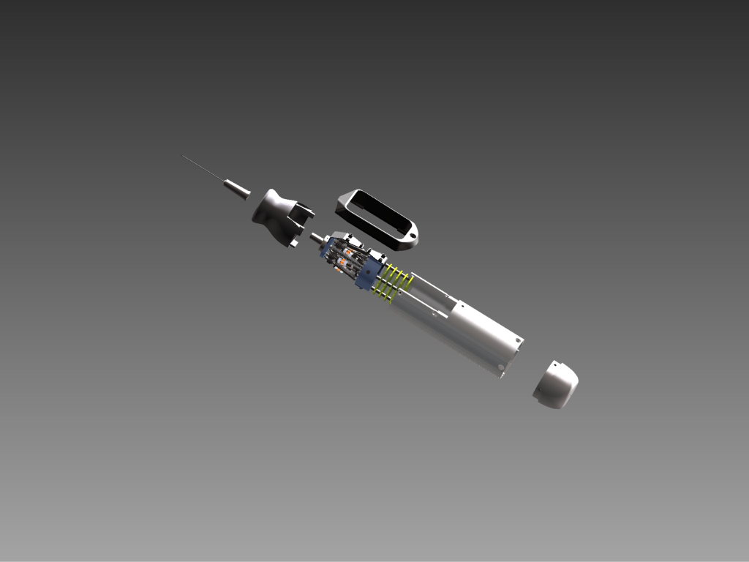

See SWYANG 020813\06242013_FigGen\ASM_Micron_All_Assembled.iam

LED flex:

We’d like to integrate our current LED flex circuit design into the handle.

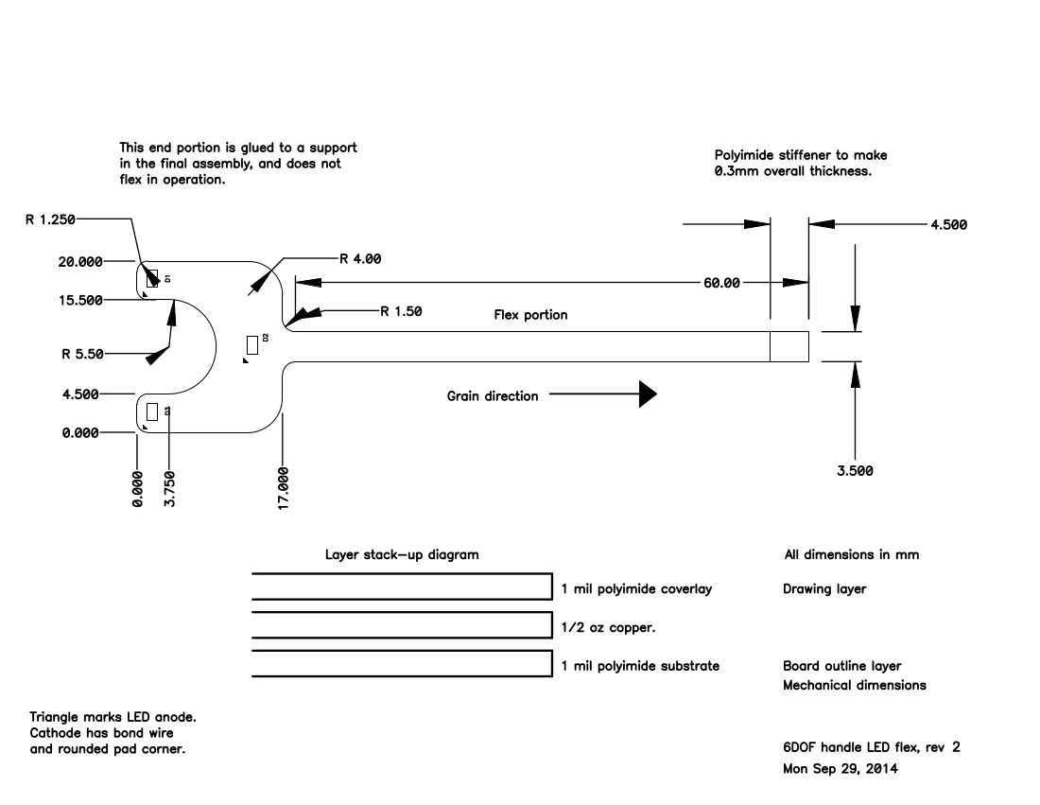

We will drive the LEDs from our box.  If you can transition our LED flex (0.5mm pitch, 6 conductor) to three twisted pairs in the cable, then that would work with either the present LEDs or a future magnetic sensor.  These pairs do not need individual shields, but should have a shield between them and the power/digital signal wires. We used OM-XF2L-0625-1. A flip-lock connector is preferable, but we didn’t have enough space between boards for that. If pin 1 is at bottom in the above drawing, then pinout is:

Anode 1

Cathode 1

Anode 2

Cathode 2

Anode 3

Cathode 3

We will bond the LED end of the flex to an approximately square plate which will screw down to a mounting point on the housing front. Screws will be in the semi-circular “mouth” cutout area, where the underlying plate is exposed. There should be a slot in the housing which will pass the connector end. I think there should be plenty of flex length.

**Mechanical overload robustness:**

Something to keep in mind is that the tool goes into a relatively uncontrolled mechanical environment, and we’d like this to stand up a at least a few years of occasional abuse. If someone drops the handpiece point down, then something bad is likely to happen. As far as I know, this has never happened (but then they probably wouldn’t have told me, either). We took the current Micron to NIH for a demo once, and one of the flexures failed at the glue bond to the aluminum base. I could see a curl of aluminum wrapped around the needle which someone had carved off of our microscope base. This flexure bond failure has been annoyingly common, but may been saving us from damaging other parts.

What I’m asking is that you think about what is going to happen when a big overload is applied to the output. Because a lot of our tools have substantial flex to them, the most likely high overload is more or less straight in (-Z direction). Bear in mind that when there is an overload while micron is on, it is very likely that stabilization is going to have driven the manipulator near to one of its travel limits (probably in the –Z direction). What do you think is the weakest part, and is it easy to repair?

I’m a bit nervous about the 0.8 mm diameter of the Shaft_platform part. For the shafts, I am much more concerned about robustness than mass or ferromagnetic material. I hope this is a springy high-strength material? If the shafts would buckle and spring back, that might be a good way of dealing with gross overload. Having the balls pop out of their sockets would also be a relatively benign failure mode. How are the balls attached to the shaft?

For what it’s worth, in our first version of the Squiggle handpiece, we went for the smallest bearings we could find, less than 1mm ID. As I recall, we started out with aluminum for the inner shaft part, and it bent before we had even got the thing assembled. In our current version, we are using a 1mm stainless shaft part to transition from the Squiggle screw to bearing.

If necessary for robustness, we could relax requirements such as the resonant frequency. In my notes about frequency response of the current manipulator <http://filter.micron.ri.cmu.edu/wiki/doku.php?id=projects:micron:system:squiggle:health_tests>, I say that with fresh flexures, open loop -3 dB is typically > 200 Hz, and when it drops below 150 Hz, this “starts to be a concern”. The resonance would be lower than the –3 dB.

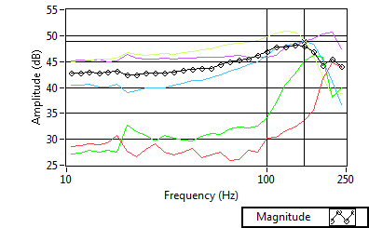

**Output plate (platform):**

SWYANG 020813\Parts\Main\ Platform_Top_14mm_Rev.ipt

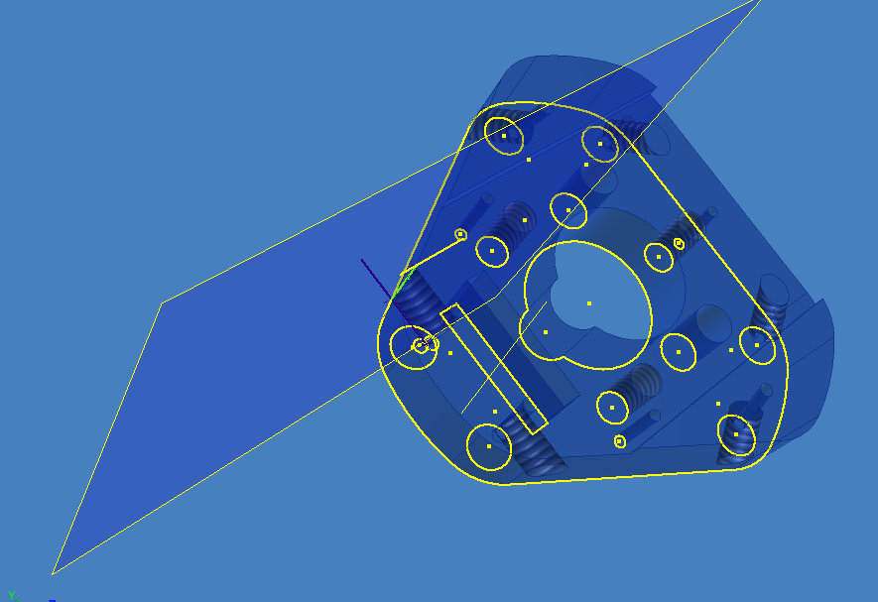

Slot for LED flex, not needed

Recess is for output LED mount, no longer needed

Three tapped holes for toolholder mounting

Not sure why this key is here.

I do like the feature that the toolholder is a separate part which we could possibly swap out if we were doing something elaborate like an actuated tool.

**Tool holder:**

This is the existing tool holder, shown with a Luer adapter and needle.

SWYANG 020813\Parts\Tool\ASM_Tool_Tip_Rev.iam

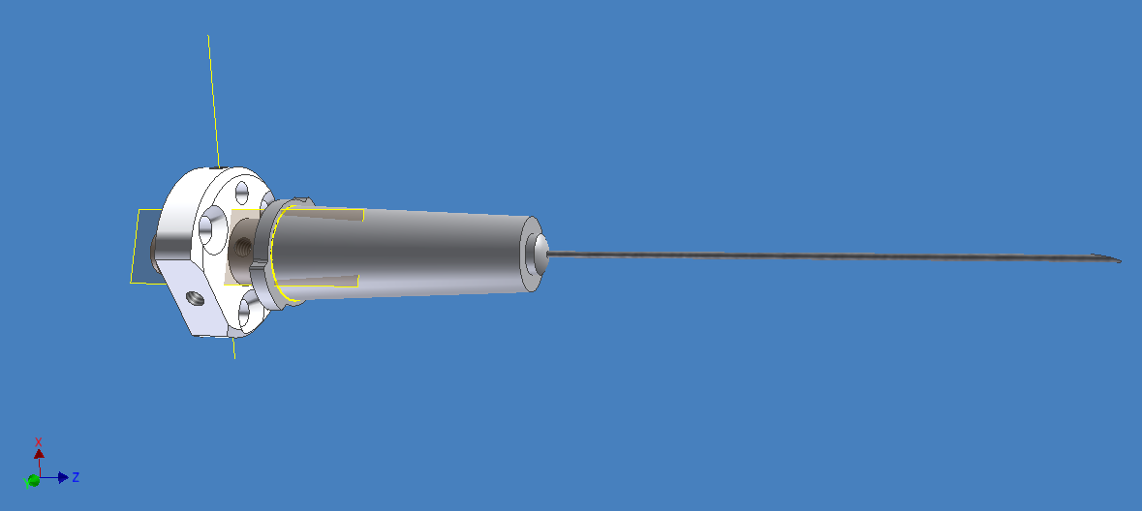

The simplest thing would be to keep the same shaft and setscrew design. But there are numerous bad things about this arrangement. First of all, I get really nervous about stripping out these tiny #00 setscrews threaded into Delrin. Aside from this, there are other nuisance factors and misfeatures.

1. We have to take off the front cover every time we want to change the tool.
2. Messing with the setscrews (or worse, trying to remove a friction-lock Luer) subjects the manipulator to uncontrolled forces at the output.
3. There is no rotational key in the toolholder. When we use tools that are not radially symmetrical about the Z axis, such as having a bent shaft, then we’d like to have some sort of anti-rotation key to make sure they get inserted in a repeatable way.

It would be really nice if there was some way to cause the tool holder to release the tool adapter (in this case, Luer) without removing the front housing and without risking damaging the manipulator. Then you could pull the adapter out through the front, connect a new tool, stick it back in, and (somehow) lock it down again.

One possibility is that before a tool change we could “park” the manipulator against the upper or lower travel limit, and this would cause a mechanical engagement that would protect the manipulator from excess forces. A lower stop would seem better, since that would protect against the more likely –Z force. We could also park the manipulator for transport, or perhaps even if we detect that the handpiece has been dropped.

It would also be possible to lock the manipulator by driving it to a particular position, then inserting two pins through holes in the side of the housing that align with holes bored through the output plate.

One possible way of locking and unlocking the tool adapter from the holder would be to use some sort of spanner with a C cross section that you could insert through the front tool opening , wrapping around the existing tool. This could engage with a collet or some other sort of holder that engages and disengages with rotation of an outer part.

Improving the toolholder would likely increase moving mass, but I think it would be worth it.

**Mass issues:**

Mass is an important consideration in the housing design:

1. We want a considerable amount of mass with a very stiff coupling to the manipulator fixed mounting part. This provides a mechanical “ground” for the control system, reducing high-frequency instabilities and smoothing out vibration.
2. We want to keep the Center of Gravity (balance point) forward so that the handpiece doesn’t want to topple backward out of the hand. Mass located at the front is also far more effective in attenuating the reaction forces resulting from XY translation of the output. It is impossible for the CG to be too far forward.
3. If it can be made to work without too much difficulty, **it would be preferable to transfer the reaction forces from the motors to a flange at the front of the motor assembly** rather than to the back end. This will move the CG forward, and will improve rigidity of the coupling between the manipulator’s “ground” and the mass in the housing front.

We initially made the manipulator base plate from plastic and experimented with various 3D printed housings and stock metal tubing. Plastic parts did not give enough mass for good performance. In the current version, the baseplate and housing are all machined aluminum, except for the back plug, which is plastic. For magnetic compatibility, **in the new NST design, fixed structural and mass parts should be 300 series stainless, not aluminum.** See **magnetic compatibility**.

The manipulator’s fixed mounting part needs a really rigid connection to the other housing components (and their mass). For CG placement, the most useful mass component is the housing front. We deliberately made the very front end far thicker than it structurally needed to be. The housing tube provides the rigid connection between the baseplate and the housing front.

The mass of the entire handpiece is ~60g, including manipulator, electronics and housing. (This weight is very approximate, since I measured with the cable attached.) We wouldn’t want it too much heavier than that.

There is more mass and strength than necessary in the back part of the housing tube, which is undesirable for forward CG placement. I think we stuck with a single part and a moderately thick wall for simplicity and ease of machining. Mass is not desirable in the housing plug, so we made this out of plastic.

**Magnetic compatibility:**

Currently we are using optical position sensing using LEDs mounted on the handpiece, but we are developing an AC electromagnetic tracker that we hope to be able to use in the future. First, a question: **Would the NST magnetic position sensors suffer significant interference from 20 uT** **(0.2 Gauss)** **AC magnetic field of** modulated at from 100 Hz to 10 kHz? This is less than typical earth field strength, and the NST sensor is DC responding, so I have hopes this would be acceptable.

In order to minimize field distortion caused by components in the handpiece, it is desirable to:

* Avoid use of ferromagnetic materials, especially soft ferromagnets such as carbon steel. high-coercivity hard ferromagnets such as permanent magnets are a lesser problem, especially if the amount of material is small, such as in the NST sensor magnets. We understand that it may not be practical or desirable to change materials in components such as the motor screw and nut. I expect that with their relatively small size, these parts will not cause too much field distortion.
* Choose low-conductivity metals such as 300 series stainless or titanium rather than high-conductivity metals such aluminum or copper. This minimizes strength of eddy currents induced by the tracker’s AC field. Interference is minimal if thickness of the part is less than one skin depth at 15 kHz (0.7mm for aluminum or 3.4 mm for 301 stainless). Parts which are small in their maximum cross section are also less of a concern.
* It’s preferable to use non-conductive materials such as plastic wherever this is consistent with the requirements for mass, stiffness and weight distribution (see **Mass issues**). Use of plastic would be attractive for the rear part of the housing, both for magnetic compatibility and handpiece balance.
* We expect we would place the tracker sensor on or inside the rear end of the rear housing. This will increase the distance from structural and mass components at the front of the handpiece. This also would place the sensor closer to the motors and power wiring, so
* Try to minimize the loop area of high current paths (the motor power supply and outputs from drivers). The EM tracker operates well below the motor resonance frequency, but current will also be varying at the position control loop update rate (1-10 kHz), which falls right within the operating frequency range.

**Position tracker LED mounting:**

Application tool moments and workspace definition:

Tip workspace volume

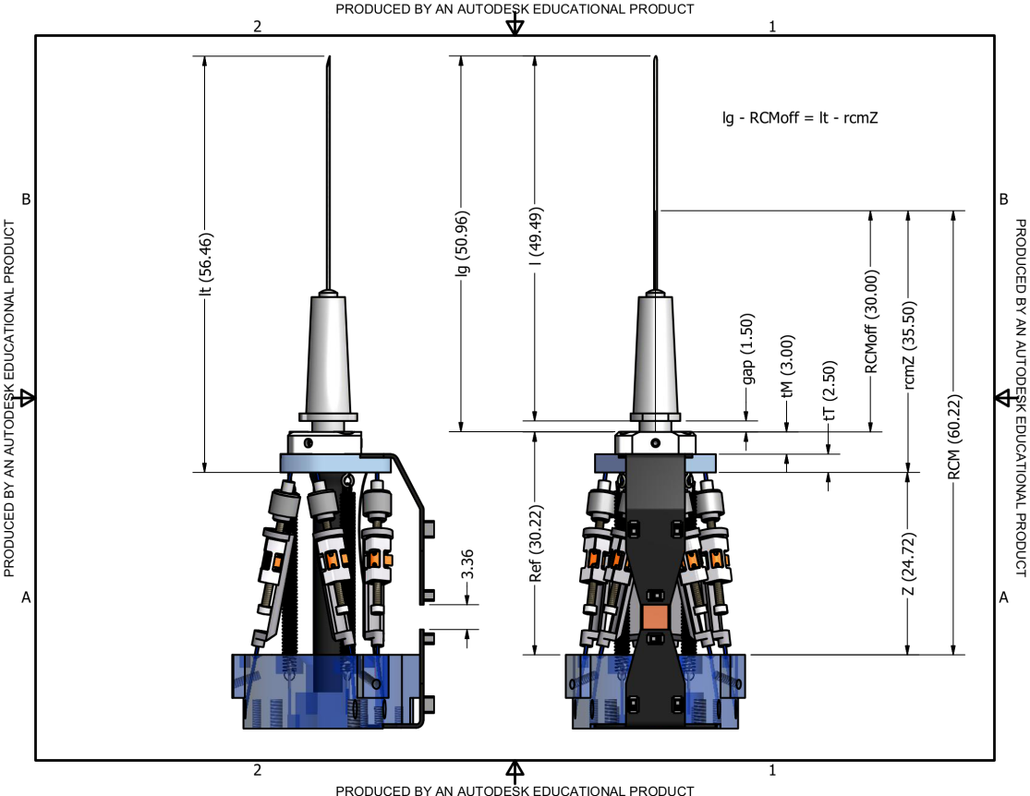

RCM pivot point

Z = 0

reference

Kinematic center

One requirement that we have used to design the manipulator is the scenario of “RCM motion”, where the RCM pivot on the tool shaft remains fixed as we move the tip throughout a cylindrical workspace. I don’t think we actually reliably achieved this with the current manipulator, but our goal was to get a 4x4mm dia tip workspace in RCM motion mode. You can see with this particular tool, the moment from RCM to tip is 20mm, vs. 37mm from kinematic center to RCM. So we need to translate nearly +/- 4mm in XY at the KC to achieve this RCM workspace. That is, more like an 8mm dia X 4mm height KC workspace.

**Workspace definition:**

Output plate

Kinematic center workspace volume

(Sets translation range)

4x4mm

Kinematic constraint circle. Tool axis must pass through this.

(Sets angular range)

4mm dia

Constraint circle is 26mm from kinematic center volume

This is the model of the manipulator workspace that I use in the kinematic code for the current manipulator. Advantages of this model are:

1. Does not depend on tool length, which is variable.
2. Does not depend on the RCM motion model, which even when we are trying to do RCM motion does not fully describe what we are actually doing to implement the commanded motion + stabilization.
3. More accurately represents the true mechanical constraint. Think of the constraint circle as representing the front opening in the handle.

I can tune these parameters to represent a good approximation of whatever the manipulator/housing combination supports. It’s easy to see that with these particular parameters and the tip/rcm positions in the previous drawing, we *can’t* reach a 4x4mm tip workspace volume using RCM motion (though we can do so without the RCM constraint). I’m not sure that Sungwook was even trying to do that with this manipulator version. Maybe 2x2?

**Baseplate:**

See SWYANG\020813\Drawings\Micron_New_Rev_Base.dwg (second page in DWG has more dimensions)

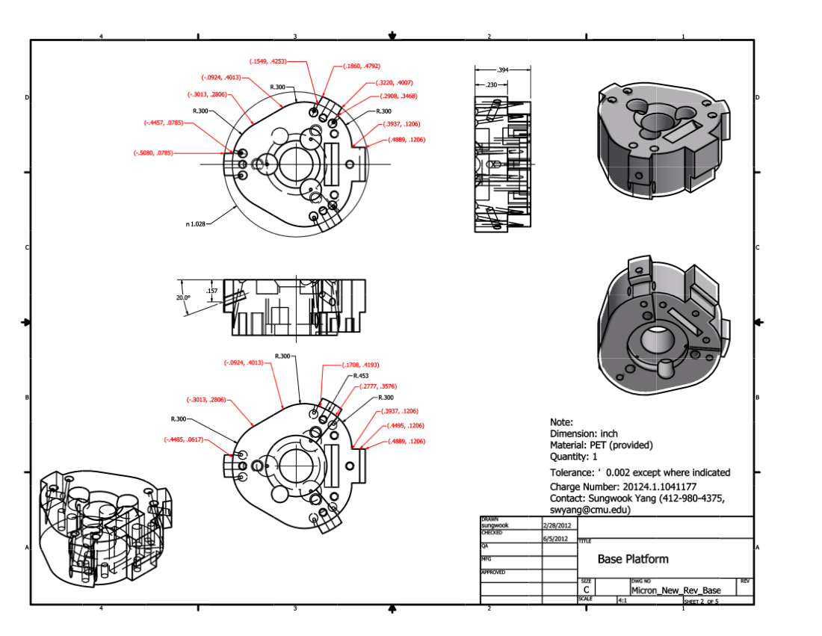

Slot for output LED flex

Footprint for base LED mount

Upper end of fiber conduit seats here

Mounting bosses seat on flange machined in housing tube. Inclined screw hole draws base down

My guess is that this particular mounting footprint for the base LED mount is not going to make sense in your design. That is, even if you can put this footprint somewhere, it may not be located correctly with respect to the window in the housing, so it would make more sense to redo the LED mount.

**Housing front:**

See SWYANG 020813\04192012_New_Front_2pcs\New_Front_Base_rev.ipt

Note excess material at front end for added mass. If you could transition your housing down to this same outer profile at the front end, that would be great. It really is not possible to handhold the tool without this part assembled on because your fingers interfere with the moving parts. The details of how this part mechanically interfaces to the rest of the housing are up to you. For what it’s worth, our screw holes in this aluminum part have stripped out from repeated reassembly. Also, as noted in **Magnetic compatibility**, this part should be made from 300 series stainless, not aluminum.

